Lambton College – Toronto
A Report on
“COVID Analysis”
Under the Subject of
2023F_AML 1214_2 Python Programming
The Pythonizers
Artificial Intelligences and Machine Learning (Section 2)

Submitted By:
Sr. No | Name | Student ID
1 | Oberoi Sakshi | C0908000
2 | Ralla Akshitha | C0912936
3 | Patel Bansil | C0912873
4 | Mohile Harsh | C0912872
5 | Bhatt Rachit | C0902810

Prof. Pouria Moderasi

ABSTRACT

This research works on various machine learning techniques to analyze the COVID-19 data. It aims to provide results on predictions related to the pandemic. This study majorly focuses on datasets gathering epidemiological information, healthcare system metrics and socio-economic indicators. This dataset is prepared for various machine learning models which include logistic regression, random forest, and long-short term memory. Employing techniques like machine learning, hyper parameter tunning and neural networks. The study contributes to the understanding of the changes and movements of pandemic that provides valuable insights of public health decision.

TABLE OF CONTENTS

ABSTRACT ii
TABLE OF CONTENTS iii
LIST OF FIGURES v
CHAPTER 1: INTRODUCTION TO THE COVID ANALYSIS 1
  - Overview 1
  - Background 1
  - Problem Statement 2
  - Objectives 2
  - Scopes of Project 3
CHAPTER 2: TERMINOLOGIES 4
- Machine Learning 4
- Hyper Parameter 4
- Natural Language Processing 4
- Numpy and Pandas 4
- Sickit Learn (sklearn) 5
- Matplotlib and Seaborn 5
- Jupyter Notebook 5
CHAPTER 3: METHODOLOGY 6
  - Study Design 6
  - Data Extraction and Exploratory Analysis 6
    - Data Extraction 6
    - Exploratory Data Analysis (EDA) 7
  - Data Validation and Cleansing 8
  - Model Development and Training 10
  - Data Visualization 13
CHAPTER 4: RESULTS AND DISCUSSION 17
  - Results 17
    - Model 1 – Logistic Regression 17
    - Model 2 – Artificial Neural Network (ANN) 17
  - Discussion 18
CHAPTER 5: CONCLUSIONS AND FUTURE WORKS 19
  - Conclusion 19
  - Future Works 19
REFERENCES 20

LIST OF FIGURES
Figure 1 Overview of the dataset 6
Figure 2 Total samples collected over the time 7
Figure 3 Total positive samples collected over the time 7
Figure 4 Total negative samples collected over the time 8
Figure 5 Outlier detection for Total Samples 8
Figure 6 Outlier detection for positive cases 9
Figure 7 Outlier detection for negative cases 9
Figure 8 Use of sequential in ANN model 11
Figure 9 Dropout and dense for ANN model 12
Figure 10 Prediction and score metrics for ANN model 13
Figure 11 Sorting dataset by plotting charts 13
Figure 12 Code for plotting pie charts 13
Figure 13 Correlation of features 14
Figure 14 Various cases in the dataset 14
Figure 15 Date-wise trends in the dataset 15
Figure 16 Top 10 states having most positive cases 15
Figure 17 Top 10 states having most negative cases 15
Figure 18 Top 10 states having total cases in general 16
Figure 19 Training log for Logistic Regression 17
Figure 20 Training log for ANN 18

CHAPTER 1: INTRODUCTION TO THE COVID ANALYSIS

Overview

Our study on COVID-19 and machine learning traces its start to the history of pandemics and the way technology has impacted healthcare. In the 21st century, the combination of data science and epidemiology has become more important, especially with the COVID-19 pandemic. This situation requires advanced tools to understand the pandemic better. Machine learning is an important tool in this situation that helps us find important patterns in large amounts of data and make decisions based on that information.

Our project is at the forefront of using technology for this purpose. We use advanced computer programs and improve our models to carefully study COVID-19 data. By doing this, we aim to help in the global efforts to fight this health crisis. We want to show how powerful machine learning is in helping us understand and deal with the many challenges of COVID-19. The next parts of our study will explain the specific ways we use machine learning, highlighting how important it is in handling the complexities of this worldwide health emergency.

Background

Understanding COVID-19 data involves looking at information about the virus. COVID-19 is a sickness caused by the SARS-CoV-2 germ, and it was declared a global problem by the World Health Organization. Data, like the number of people who got sick, passed away, got better, and how many were tested or vaccinated, comes from different places like health groups and research teams. Sometimes it's tricky because not all places report the same way, and some people might have the sickness but not show any signs. Looking at how things change over time helps us see patterns and how things like staying home or getting vaccinated affect the situation. It's not just about sickness; it's also about how it affects our lives, jobs, and different groups of people. Pictures and graphs help make the information easier to understand, and we need to be careful about privacy when dealing with this kind of data.

Problem Statement

This project desires to grapple with the complex challenge of predictive analysis of COVID-19 through the deployment of machine learning as a fundamental tool. The primary concern is to increase our understanding about the virus's spread and its impact along with the mitigation strategies by utilizing various algorithms of machine learning for performing predictive analysis and identifying the trends in the data. It involves emphasizing key points like data preprocessing, feature selection, engineering, and modeling to ensure the evolution of a durable framework. The project prioritizes the dire requirement for effective predictive modeling to find useful insights like health decisions, resource allocation, and policy amendments to inform the public.

We aim to make a balance between efficiency and accuracy, by taking the importance of rapid model convergence and training speed into consideration. The main target is given to alleviating challenges such as data noise, dealing with dynamic pandemic scenarios, and achieving high performance of the model. Delving into the research, our objective is to contribute to the global efforts to deal with the complexities of the pandemic utilizing the advanced methodologies of machine learning.

Objectives

The primary goal of our project is to perform predictive analysis for the pandemic COVID-19 accurately to unravel insightful trends that will be helpful for the Healthcare industry. Leveraging various algorithms and machine learning techniques, we aim to outstrip the traditional approaches to analysis and obtain enhancement in the accuracy of prediction. Further, the objectives include evaluating the impact of the usage of various methods of data preprocessing, feature selection methodologies, and the whole analysis done for the prediction in enhancing the overall robustness along with efficiency. Additionally, we target to apply this optimized model to real-world scenarios to contribute valuable information for better public health decision-making, strategy formulation and resource allocation.

  - Scopes of the Project

The scope of this project in COVID-19 analysis using machine learning is to analyze the dataset from the pandemic. In healthcare, the developed models can be applied for early detection and prediction of COVID-19 outbreaks, contributing to resource allocation and healthcare planning. The integration of machine learning algorithms can enhance diagnostic processes, supporting medical professionals in accurately identifying and classifying COVID-19 cases from medical imaging data. Furthermore, these models can contribute towards enhancement of treatment strategies and the identification. For the health sector machine learning can be employed for the analysis of epidemiological data, enabling the identification of high-risk areas. The scalability of this machine learning approach positions can be considered as tackling strategy to encounter the presented by the COVID-19 crisis, depicting data for meaningful contributions in the respective fields.

CHAPTER 2: TERMINOLOGIES

  - Machine Learning

Machine learning is a technology that enables computers to learn and make decisions without being explicitly programmed. The machines learn from patterns and data. There are 2 types of machines learning namely, supervised, and unsupervised. In supervised learning, the computer is trained on a labeled dataset, where it learns to make predictions or identify patterns based on input and output pairs. Unsupervised learning involves the computer finding patterns and relationships in data without specific guidance.
  - Hyper Parameter Tuning
Hyperparameter tuning in machine learning works on adjusting the settings, called hyperparameters, of a model to enhance its performance. Hyperparameters are configurations that are set before the training process begins, and they are not learned from the data like the model parameters. The goal of hyperparameter tuning is to find the best combination of these settings that results in the highest performance for specific ML tasks. This process often involves trying out different values for hyperparameters, training the model, and evaluating its performance until the optimal configuration is found.
  - Natural Language Processing
Natural Language Processing is like a language helper for computers. It helps them understand, talk, and respond to people better. Imagine it doing tasks such as understanding text, talking like humans, recognizing speech, translating languages, answering questions, and sorting text into categories. NLP uses a mix of language and learning tricks to make machines smart about how we communicate. You see it in things like virtual helpers, language translators, and figuring out feelings in social media. It basically makes talking to computers feel more like talking to a friend.
  - Numpy and Pandas
NumPy stands for Numerical Python: - It provides support for large, multi-dimensional arrays and matrices, along with mathematical functions to operate on these arrays. NumPy is very important for computing tasks scientifically, such as linear algebra operations, and useful for many data science libraries.
Pandas: - library is built on top of NumPy and provides high-level data structures, such as Data Frame, which is a two-dimensional, tabular data structure. Pandas are excellent for handling and manipulating structured data, offering functionalities like indexing, grouping, filtering, and merging datasets. It is widely used for data cleaning, exploration, and preprocessing tasks.
  - Scikit Learn (sklearn)
Scikit-learn is an open-source machine learning library that provides simple and efficient tools for data analysis and modeling. Scikit-learn is built on NumPy, SciPy, and Matplotlib, and it integrates well with other popular Python libraries. The library includes a wide range of machine learning algorithms for classification, regression, clustering, dimensionality reduction, and more. It also provides tools for model selection, evaluation, and preprocessing of data.
  - Matplotlib and Seaborn

Matplotlib is used for general graphical representation like graph, bar, pie and many more. It is one of the in-built libraries of the python we just import it by calling the import function of the python.
Seaborn is used as the advanced version of the graphical representation of the analysis you have done in the machine learning to better understand of the trend and can visual it properly.
  - Jupyter Notebook

Jupyter is the open-source web application that help us to create documents which contain real-time code, equations, and many more. These documents can be shareable with others as well.

CHAPTER 3: METHODOLOGY

Study Design

In this dataset we have total 16336 row x 5 feature gather around the Indian state. We have found the different samples collected within each state on the different date and from that our 2 features are positive or negative which stands as the sample each day has how many covid positive cases and how many negative cases on that day. We have displayed the dataset trend graphically as well. We use different classifying algorithms like random forest and logistic regression. We use LSTM from the neural language processing in which we given the 100 epochs as the in which we have early stopping as our model start declining the accuracy score.

Data Extraction and Exploratory Analysis

Data Extraction
The process of retrieving specific information from a large dataset. It involves identifying and considering relevant data points required to meet a particular purpose or analysis. This can include collecting information from various sources, such as databases, documents, or websites, and extracting the key details needed for further examination.
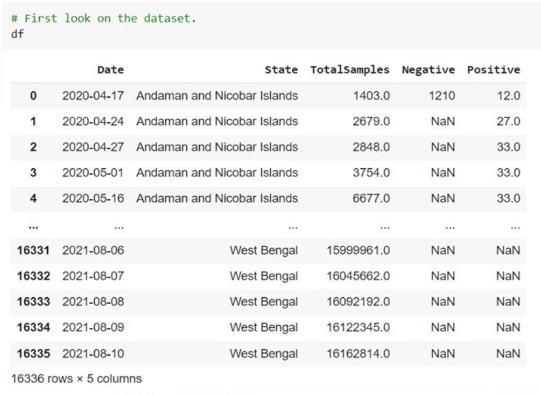
Figure 1 Overview of the dataset

Exploratory Data Analysis (EDA)

Exploratory Data Analysis is an approach of data analysis that acts visually and statistically examining datasets to understand and summarize their main characteristics, the main goal of this analysis is uncovering patterns, trends, relationships, or anomalies. EDA involves various techniques such as data visualization, summary statistics, and graphical representations, for deeper understanding of the structure and nature of the data.

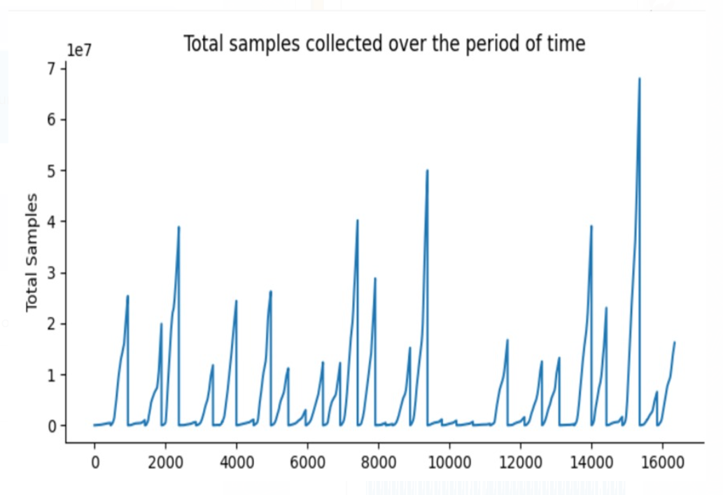
Figure 2 Total samples collected over the time

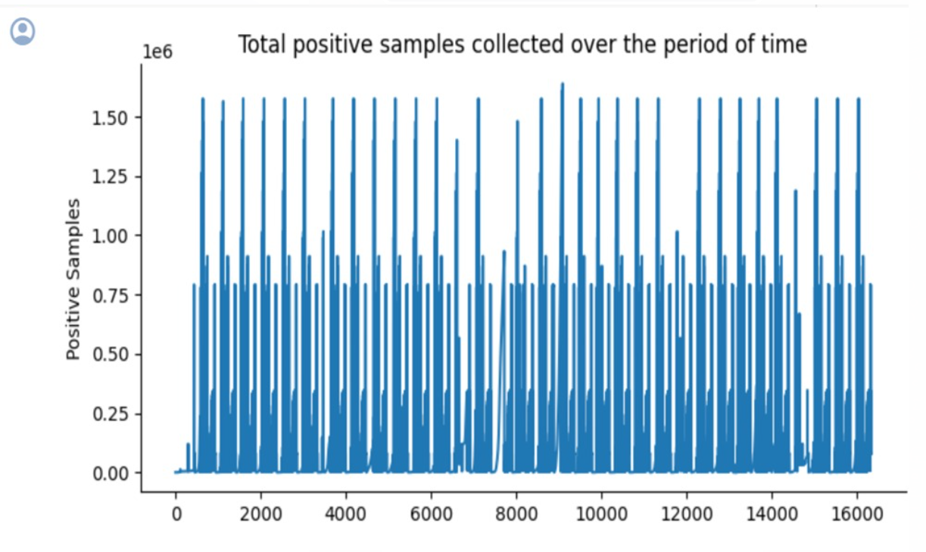
Figure 3 Total positive samples collected over the time

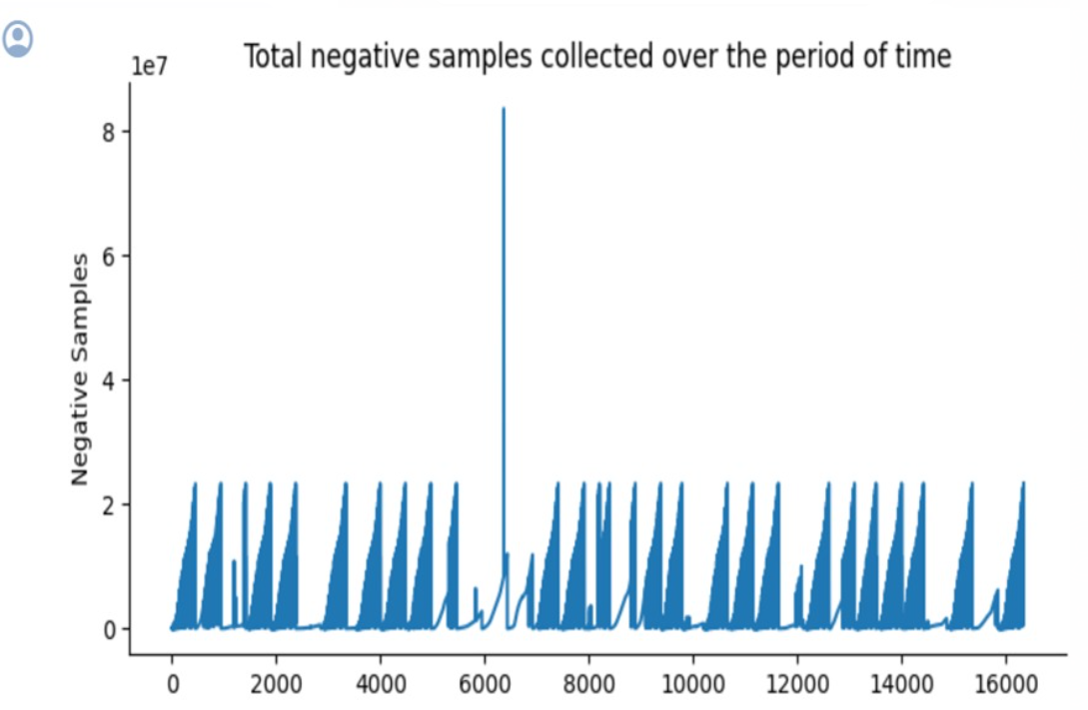
Figure 4 Total negative samples collected over the time

3.3 Data Validation and Cleansing

Data validation and cleaning is the most crucial part of data preprocessing. It includes cleansing, transforming the data to an understandable format. The missing values, null values, renaming the columns, finding outliers is done.

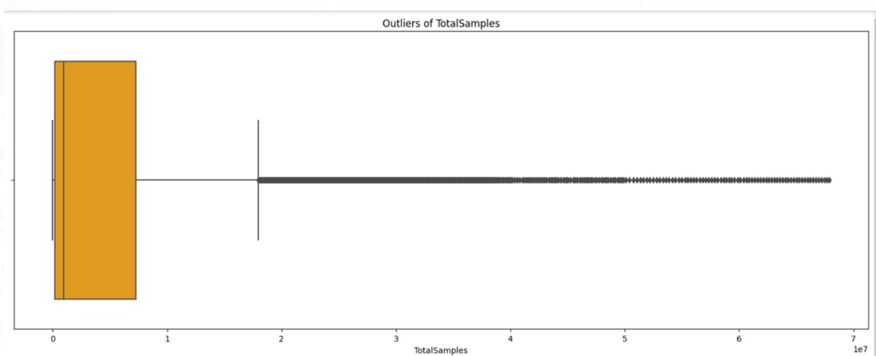
Figure 5 Outlier detection for total samples

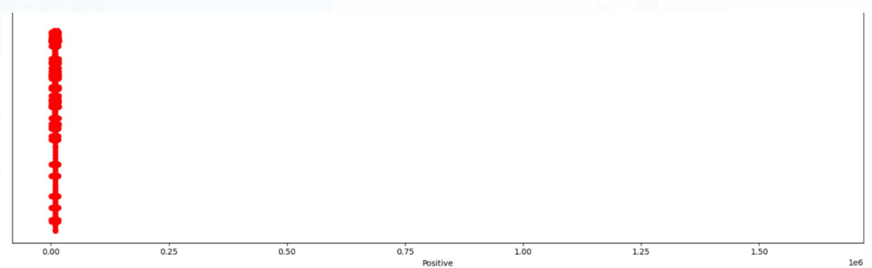
Figure 6 Outlier detection for positive cases

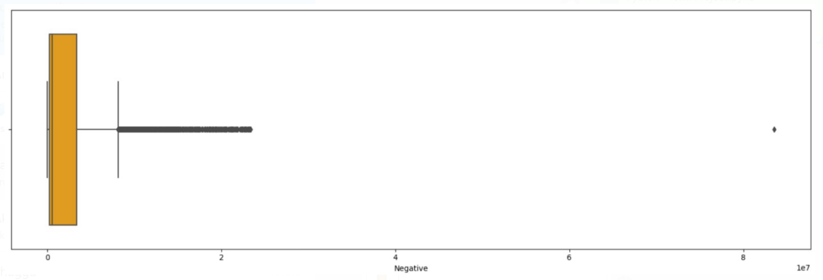
Figure 7 Outlier detection for negative cases

Model Development and Training

The analysis is done by utilizing popular ML techniques with the help of Python and Jupyter Notebook. First, Logistic Regression model is implemented to predict the testing data based on the training dataset which was split before applying the model from the overall dataset in 75% - 25% split. The accuracy and various metrics are shown thereafter. Secondly, we have applied Artificial Neural Network with 20 epochs in a batch size of 128. Additionally, we added the EarlyStopping and ReduceLROnPlateau to save some time and accurately attempted in going towards the global minima having patience as 5 attempts. The initial results were not good; however, the accuracy had a rise after reaching by the end of the epochs and reducing the learning rate when exceeding the patience limit. Also, we have included dense to model and adding multiple layers with the Dropout for the connected layers for our neural network model. With the help of EarlyStopping and ReduceLROnPlateau made an ease on saving time and understanding how our model responds to the parameters.

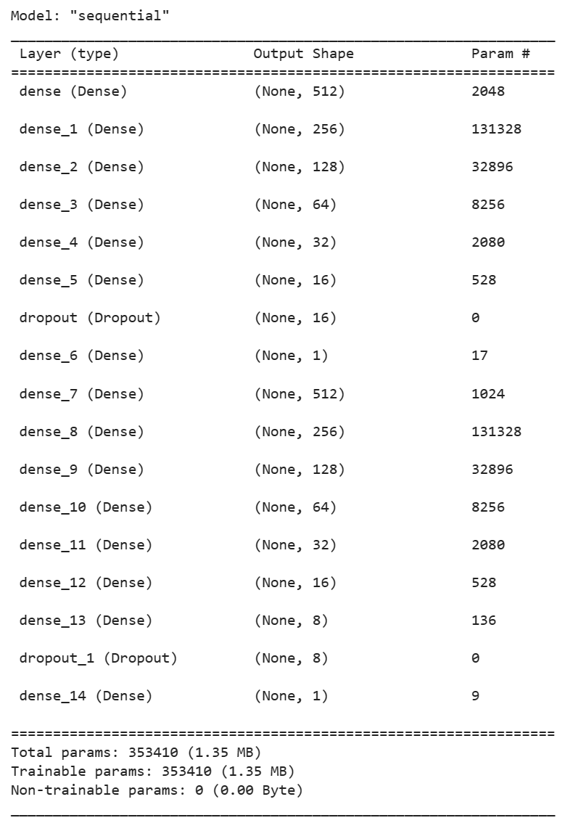
Figure 8 Use of sequential in ANN model

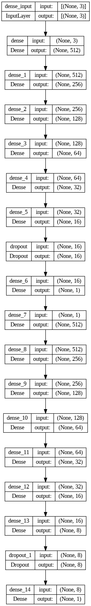

Figure 9 Dropout and dense for ANN model

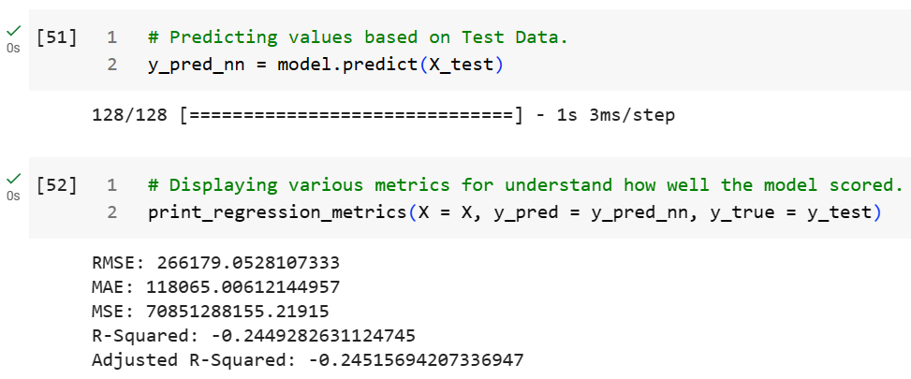
Figure 10 Prediction and score metrics for ANN model

Data Visualization

The graphical representation of data using various visualizations for a deep understanding of the data analysis is known as data visualization. These visualizations help better communication. Our visualizations include the heat map, pie chart, and bar plots.

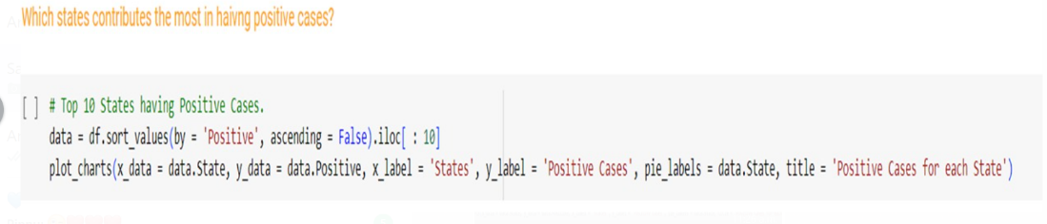
Figure 11 Sorting dataset by plotting charts

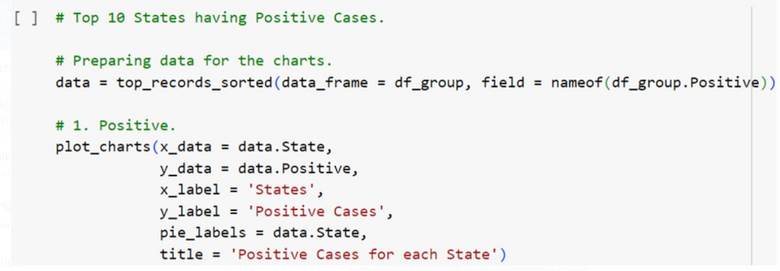
Figure 12 Code for plotting pie charts

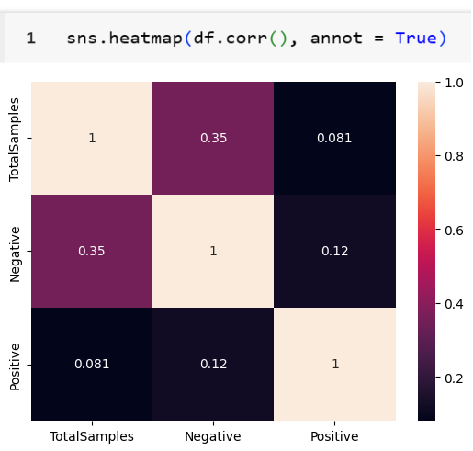
Figure 13 Correlation of features

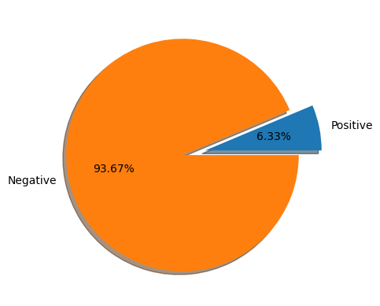
Figure 14 Various cases in the dataset.

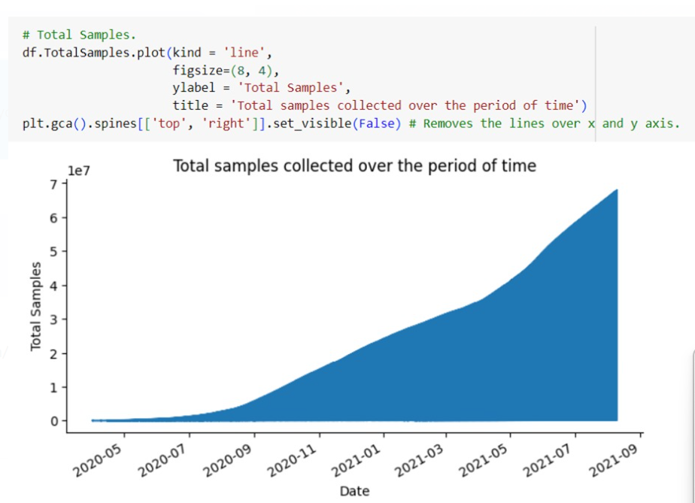
Figure 15 Date-wise trends in the dataset

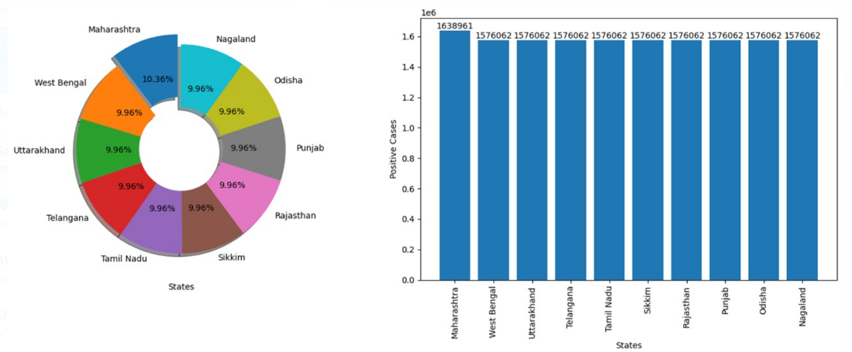
Figure 16 Top 10 states having most positive cases

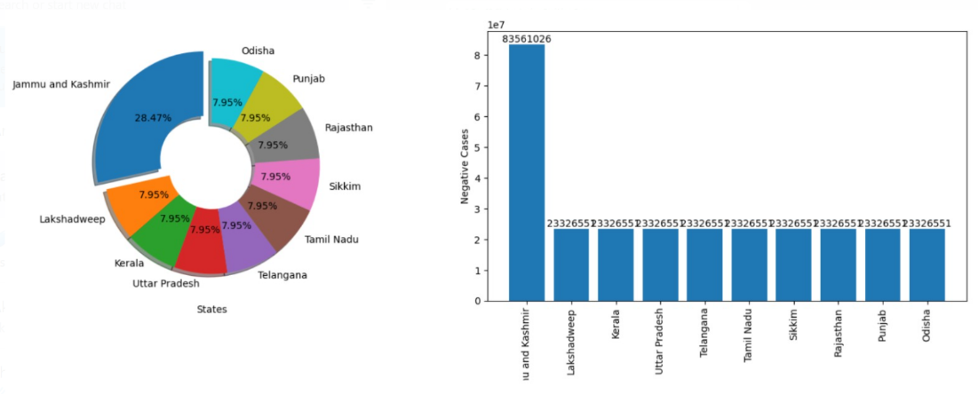
Figure 17 Top 10 states having most negative cases
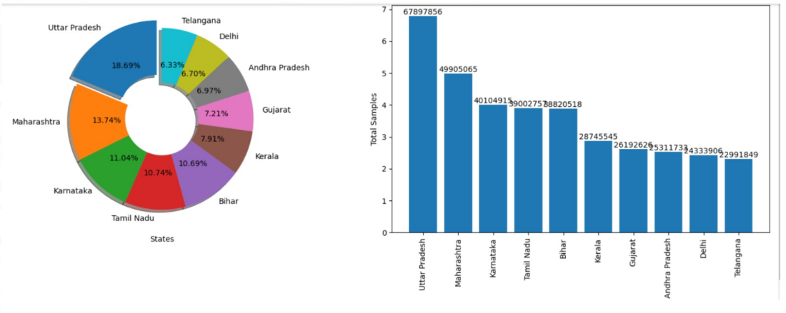
Figure 18 Top 10 states having total cases in general

CHAPTER 4: RESULTS AND DISCUSSION

Results

The results of the digit recognition experiments are presented for the different neural network architectures.

Model 1 – Logistic Regression

In the Logistic Regression, target variable was defined as Positive cases which depends on the date (Year, Month, and Day). After predicting the test dataset as retrieved while splitting the data, the predictions were not linear as shown in the figure below and provided an accuracy of 13.95%. Once the metrics were disclosed, it was clear that there is required to filter the data or go with another model to resolve the problem of such a low accuracy.

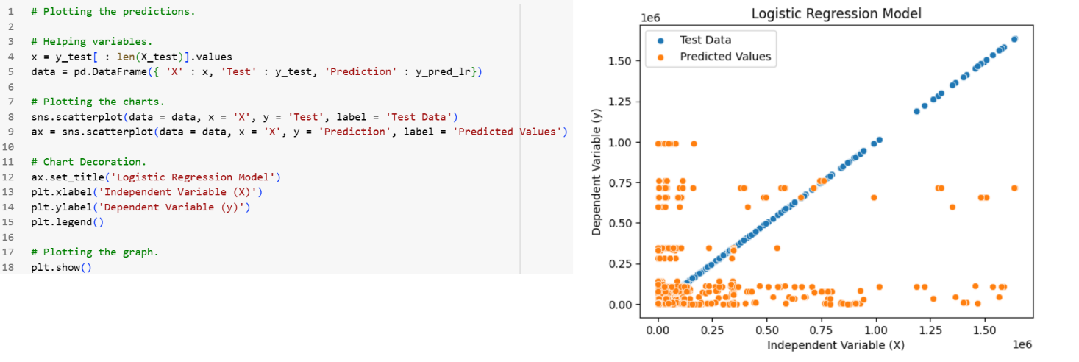
Figure 19 Training log for Logistic Regression

Model 2 – Artificial Neural Network (ANN)

For model 2, a multi-layered neural network, the training logs of the neural network model over 20 epochs are shown below. The "loss" and "accuracy" metrics are reported for both the training and validation sets. In the initial epoch (Epoch 1), the training loss is relatively high (62M), and the training accuracy is 0.62%. The validation loss and accuracy are more favorable (61M and 0.55%, respectively). As training progresses, the model's training loss decreases, indicating that it is learning to fit the data better, but the validation loss begins to fluctuate and increase from the second epoch onwards, potentially indicating overfitting. The training accuracy remains high, while the validation accuracy varies, suggesting that the model might not generalize well to unseen data. These trends continue across subsequent epochs, with the model's performance gradually deteriorating, particularly in terms of validation accuracy. The final epoch shows a training loss of 62M, training accuracy of 0.56%, validation loss of 69M, and validation accuracy of 0.62%. Overall, the model appears to underfit the training data and struggles to perform well on unseen validation data, suggesting a need for further optimization or adjustments to prevent underfitting.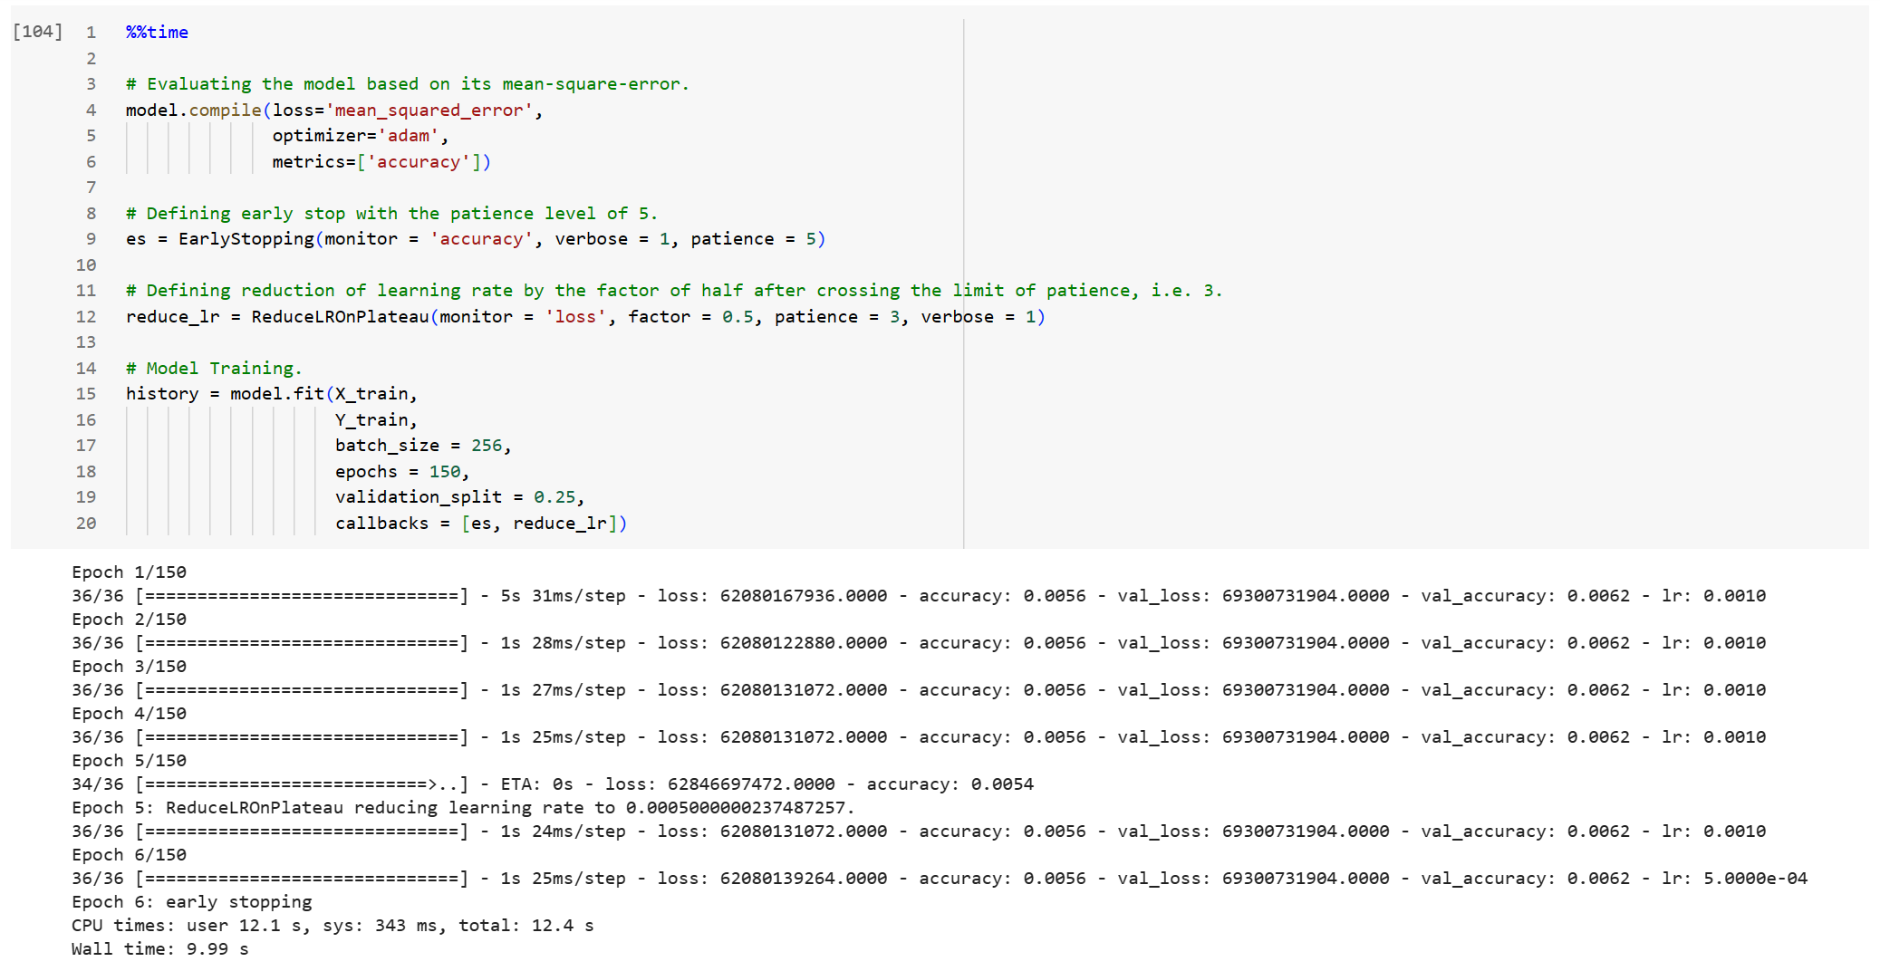
Figure 20 Training log for ANN

Discussion

This project shows how we use machine learning to understand COVID-19 data better. We carefully built, trained, and checked our computer models, using different methods. We also used pictures to help us see the data more clearly and find important information about how the virus spreads. The models we made are good at predicting what might happen next with the virus. This makes them useful for real-life situations. We made sure our models work well in different situations, showing that they are strong and can handle different challenges. Overall, this project proves that machine learning is a helpful tool for making decisions based on evidence, and it gives useful tools for doctors and leaders dealing with the problems caused by COVID-19.

CHAPTER 5: CONCLUSIONS AND FUTURE WORKS

Conclusion

In conclusion, using machine learning to study COVID-19 has helped us learn important things about how the virus acts. We made smart computer models by carefully choosing what information to look at and getting the data ready. These models are good at predicting risks accurately. Using different methods and getting information in real-time has made our predictions more dependable. We need to remember that there are still things we don't know about the virus because it keeps changing. This shows why scientists, doctors, and leaders need to keep working together. Even though it's hard, using machine learning for COVID-19 is a strong tool to help make good decisions about public health and where to use our resources to fight the virus.

Future Works

The scalability of machine learning models is huge. The learnings from covid-19 analysis can be applied to analyze various health challenges. More machine learning models can be used for analysis and prediction and this analysis can be done for better accuracy, not only for covid-19 but also for various diseases.

This kind of predictions in various health care challenges will help in approaching medication in early stages and get personalized treatments. As per our analysis, machine learning is elevating and largely enhancing our analysis and highlights our responses to public health concerns.

REFERENCES

SRK and Devkumar K. P. (2019) COVID-19 in India. Kaggle. https://www.kaggle.com/datasets/sudalairajkumar/covid19-in-india/data

